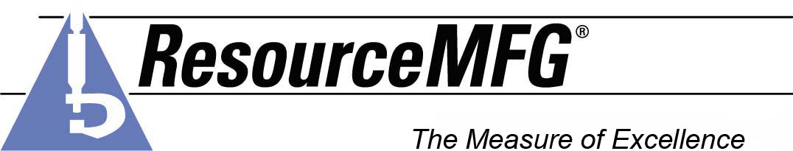 HUBERT MEDINA
2005-2007 Home Depot Tucson, AZ
Experience
Building Lumber Freight Team Associate
- Provide customer service
- Operates forklift safely at all times following all safety rules and regulations.
- Perform daily inspections of forklift as required by OSHA and Home Depot Company standards.
- Notify Supervisor of any necessary equipment maintenance/repair.
- Band lumber product for storage or shipping.
- Assist in moving of inventory for storage within the yard area as directed.
- Properly store inventory – level and covered as necessary.
- Assists in inventory and/or cycle counts as directed.
- Operate saw equipment for lumber intermittently.
- Assist in keeping all lanes and areas clean and clear for traffic
- Safely, accurately, courteously loads product on customer’s truck/trailer.
- Reads hand written or system generated sales order to determine product.
- Notes all special instructions for filling an order.
- Accurately pull will call orders and stages for loading as directed.
- Accurately pull delivery orders and package as directed.
- Load product on trailers for delivery
- Perform other work related duties as assigned by supervisor
2004-2005 O’Reilly Chevrolet Tucson, AZ
Maintenance Worker
- Responsible for upkeep, and cleaning of automobile dealership facilities
- Performed general maintenance and repair in buildings and structures
- Installed, repaired, and maintained machinery, plumbing, physical structure, and electrical wiring and fixtures of facility in accordance with blue-prints, manuals, building codes, and safety regulations, using hand tools and carpenter's, electrician's and plumber's tools
- Inspected machinery and mechanical equipment for defects
- Repaired or replaced electrical wiring and fixtures
- Constructed and repaired partitions and other wooden structures, using saws, braces, bits, and appropriate materials and tools;
- Painted walls, floors, woodwork and fixtures, using appropriate materials and tools;
- Replaced and repaired brick and plaster walls, using appropriate materials and tools;
- Installed, repaired, and replaced gauges, valves, pressure regulators, and other plumbing equipment, and opened clogged drains, using appropriate tools;
- Operated arc welding equipment to join metal parts used to repair or fabricate equipment;
- Observed safe work practices and procedures at all times
- Attended in-service training to develop and improve knowledge and skills of a proficient maintenance worker
- Adhered to proper cleaning methods, storage, and proper care of equipment and supplies.
- Kept maintenance records as required on equipment and job site
2003-2004 Kelly Electric Technologies Tucson, AZ
Warehouse Driver
- Transported skid steers, scissors lifts, ditch switches to and from job sites
- Organized electrical parts in warehouse
- Transferred electrical equipment to and from job sites
- Knowledge of electrical parts and supplies as needed for jobs
2002-2003 Onsite Companies Tucson, AZ
Forklift Operator
- Shipping & Receiving Finished Goods
- Loading and unloading freight from trailers
- Move freight to all sections of the warehouse
- Scan freight into computer
- Drop freight for assembly workers
- Load steel shelving
- Operate Electric Pellet Jacks
- Operate Reach Truck
- Labeled products
- Daily Inspection of the lift truck paying particular attention to the brakes, lights, horn and controls and pallets
1989-2002 Costco Wholesale Warehouse Tucson, AZ
Forklift Operator
- Operated electric pellet jack
- Completed the Costco forklift certification program
- Completed a thorough safety inspection of the lift truck paying particular attention to the brakes, lights, horn and controls and pallets daily
- Knowledge of lift truck load limits
- Moved freight to all sections of the warehouse
- Dropped freight for stockers
- Trained new employees on stocking merchandise
- Loaded steel shelving
- Received freight at dock by loading and unloading from trailers
- Cashiered at checkout as needed using IBM registers
1984-1989 Costco Wholesale Warehouse Tucson, AZ
General Business Maintenance Worker
- Preventive maintenance on 35 evaporative cooler units
- Electrical Troubleshooting and Repair
- Experienced in the use of hand and power tools
- Performed plumbing maintenance
- Performed building maintenance
- Performed various welding jobs
- General Carpentry and Repair
- Replaced Sheet Rock and plastering as needed
- Performed custodial work
- Maintained facility grounds
1980-1984 Phelps Dodge Corporation Morenci, AZ
Welder
- Welded heavy equipment machinery
- Preventive maintenance of conveyor belts
- Operated forklifts and boom trucks
- Smelter Repair

